**DOGFISH POP-OFF SATELLITE TAGGING INSTRUCTIONS**

**\*\*READ DETAILED INSTRUCTIONS IN OPS MANUAL BEFORE STARTING\*\***

|  |  |
| --- | --- |
| **Step 1**. Only select fish >70 cm PCL (Fig. 1). Check that the first dorsal spine is intact. These can be kept in the live tank until step 3. | **Step 2.** Collect tags to be deployed. Gently remove from case and pull of tape/magnet (do not throw away!). Check attachments for all parts: mono, tube, 2 crimping sleeves. Let sit. Collect tools: needle nose pliers, power drill, 5/64 drill bit, crimper. |
| **Step 3.** Have one person hold shark. Record tag number, shark PCL, and sex on data sheet. | **Step 4.** Find spot above the base of the fin to drill. Drill hole through spine horizontal. If spine breaks, release animal. |
| **Step 5.** Feed loose end of mono through hole and back into crimping sleeve. Use pliers to make it as tight as possible. | **Step 6.** Crimp sleeve through the tubing, so that it hangs to the side of shark. |
| **Step 7.** Observe in recovery tank for a few minutes then release over the side. | |

**\*\*\*SUPPLEMENTAL INFORMATION\*\*\***

**DOGFISH POP-OFF SATELLITE TAGGING INSTRUCTIONS**

**Attachment Failure**

* If for some reason you feel that the tag is not attached correctly, go ahead and cut it off the animal and release the animal.
* If you do not plan to deploy the removed tag the same day, replace the magnet and tape and put tag back into case (Figure 1). Make sure that the magnet covers the white spot.

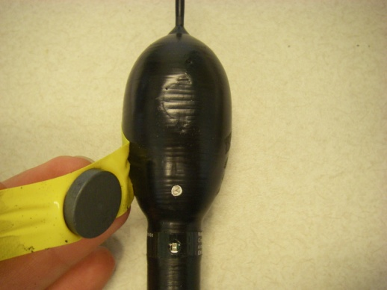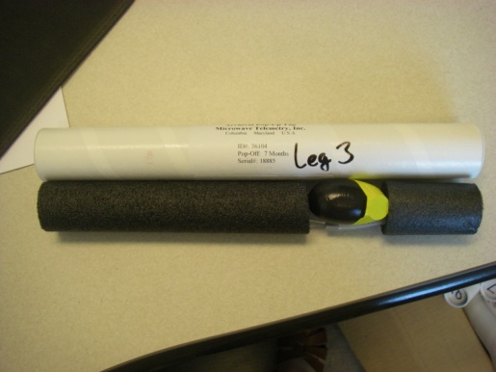

Figure 1. Left – replacing tape and magnet over white spot. Right – placing tag into foam and back into tag case.

**Making a New Attachment**

* For tags that were removed from sharks, a new attachment will need to be made.
* Supplies (Figure 2):
  + Nalgene tube (pre-cut)
  + 300lb test mono (pre-cut)
  + 2 SS crimp sleeves
  + Crimper

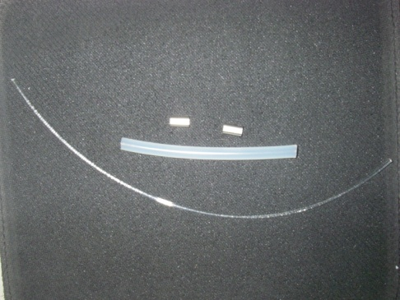

Figure 2. Attachment supplies

**Step 1.** Feed end of mono through small loop at base of tag, then back through crimp. Mono loop needs to be large enough so that crimp is at least 1” from base of tag. Crimp sleeve.

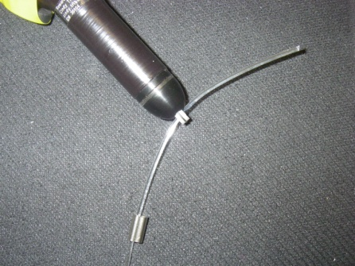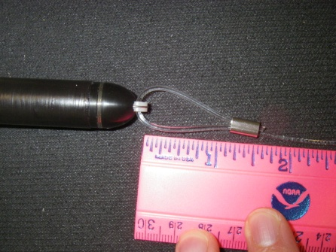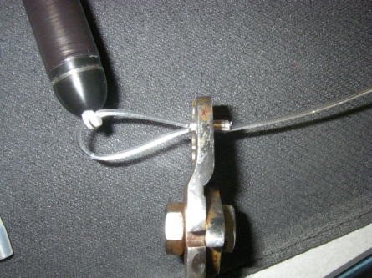

**Step 2.** Slide nalgene tubing over mono and crimped sleeve.

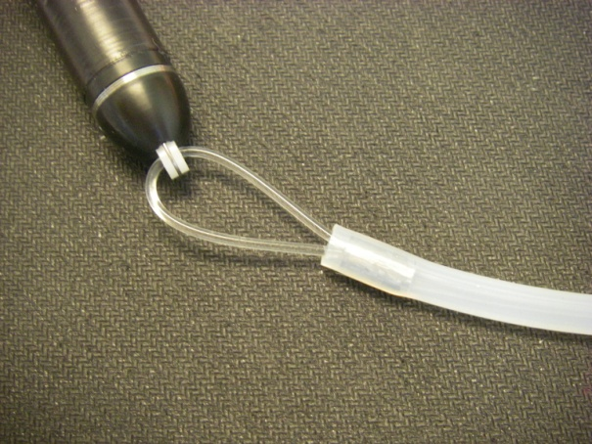

**Step 3.** Slide remaining crimping sleeve into other end of nalgene tubing. You’re now ready to tag!

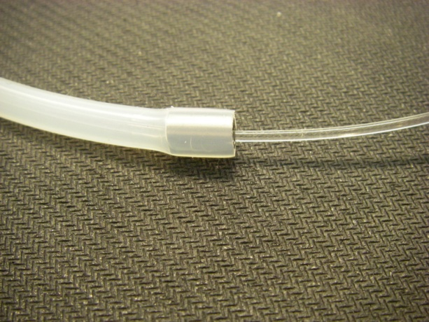

**DOGFISH PETERSON DISK TAGGING INSTRUCTIONS**

**\*\*READ DETAILED INSTRUCTIONS IN OPS MANUAL BEFORE STARTING\*\***

These tags are used to externally identify sharks that have surgically implanted archival tags. Do not use the nylon T-bar “reward” tags that are normally used!!!

**Step 1.** Supplies: 2 pins, 2 syringes, 2 pink “reward” tags, needle nose pliers

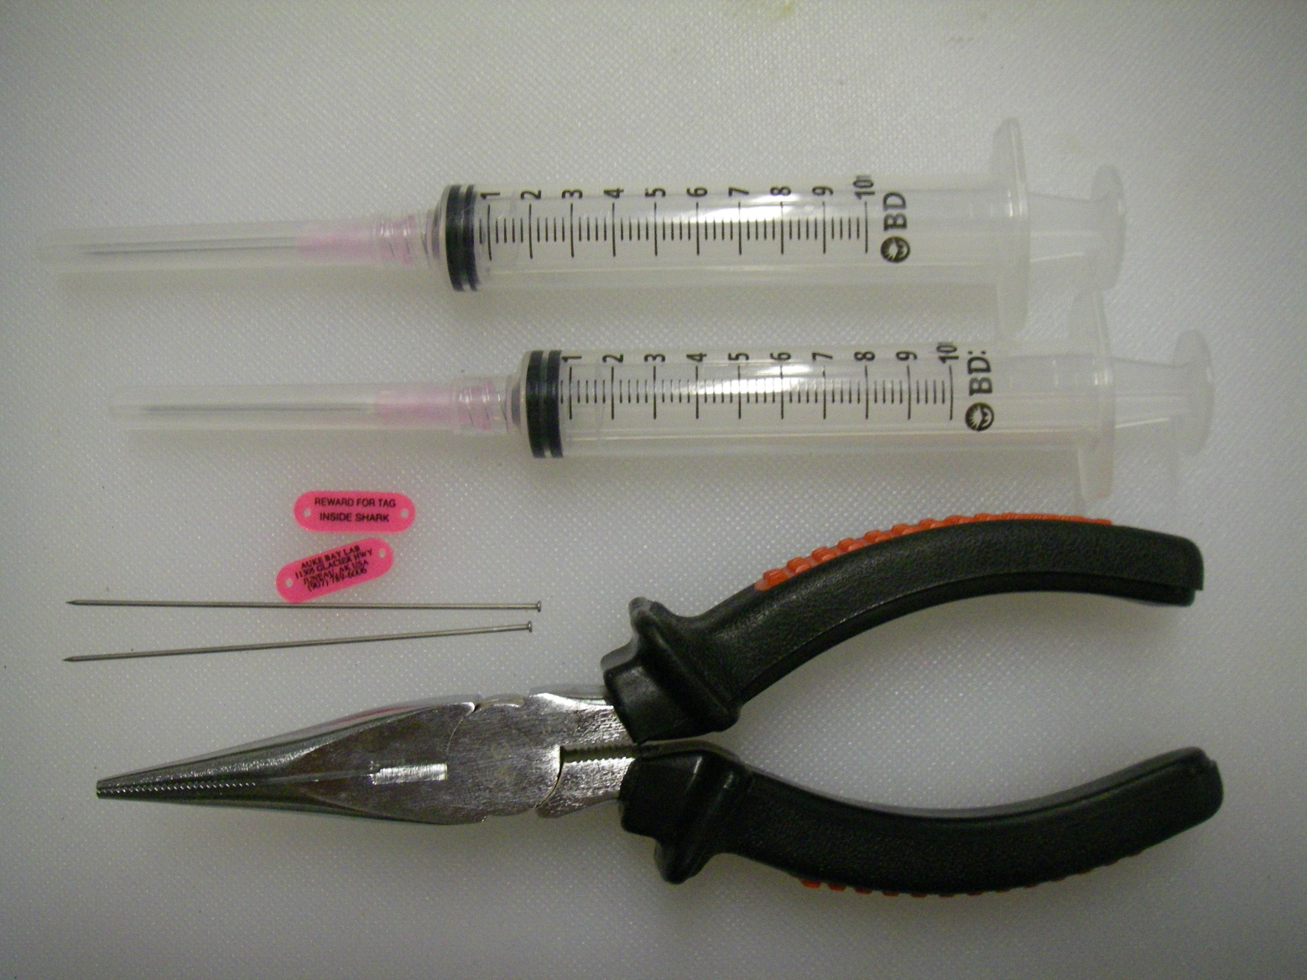

**Step 2.** Assemble 2 syringes with 1 tag and 2 pins with 1 tag(figure 3), be sure that opposite sides of the tags will be sticking out when done.

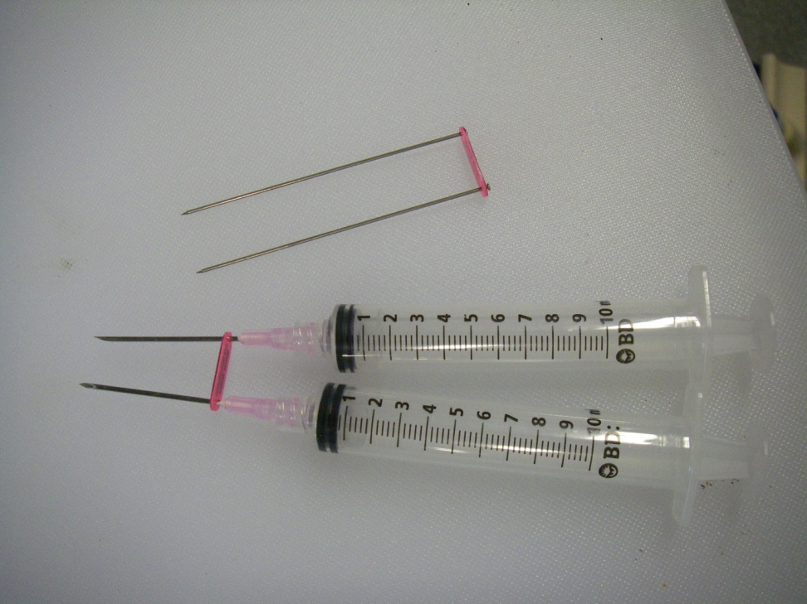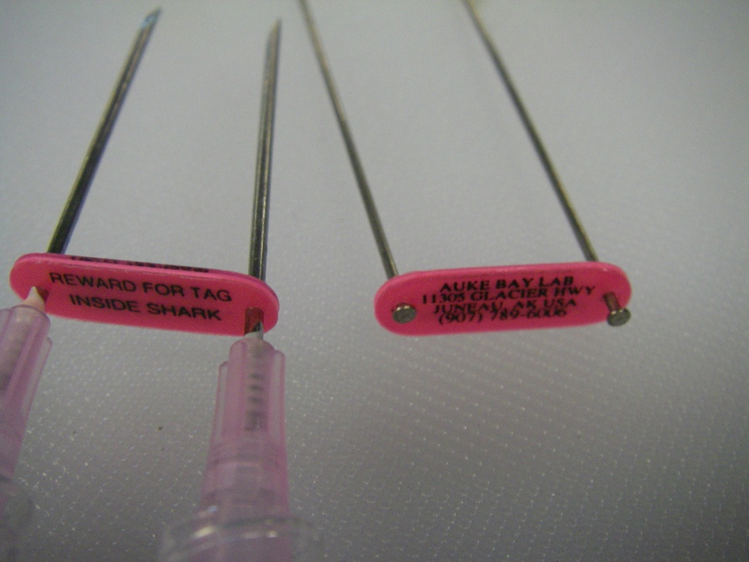

**Step 3.** Locate a spot at the base of the first dorsal fin. With air in the syringes, press both (with tag) through the dorsal fin. Try to keep them parallel.

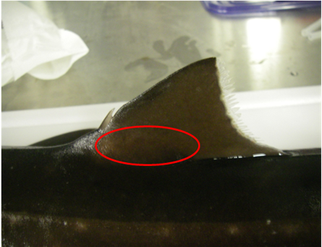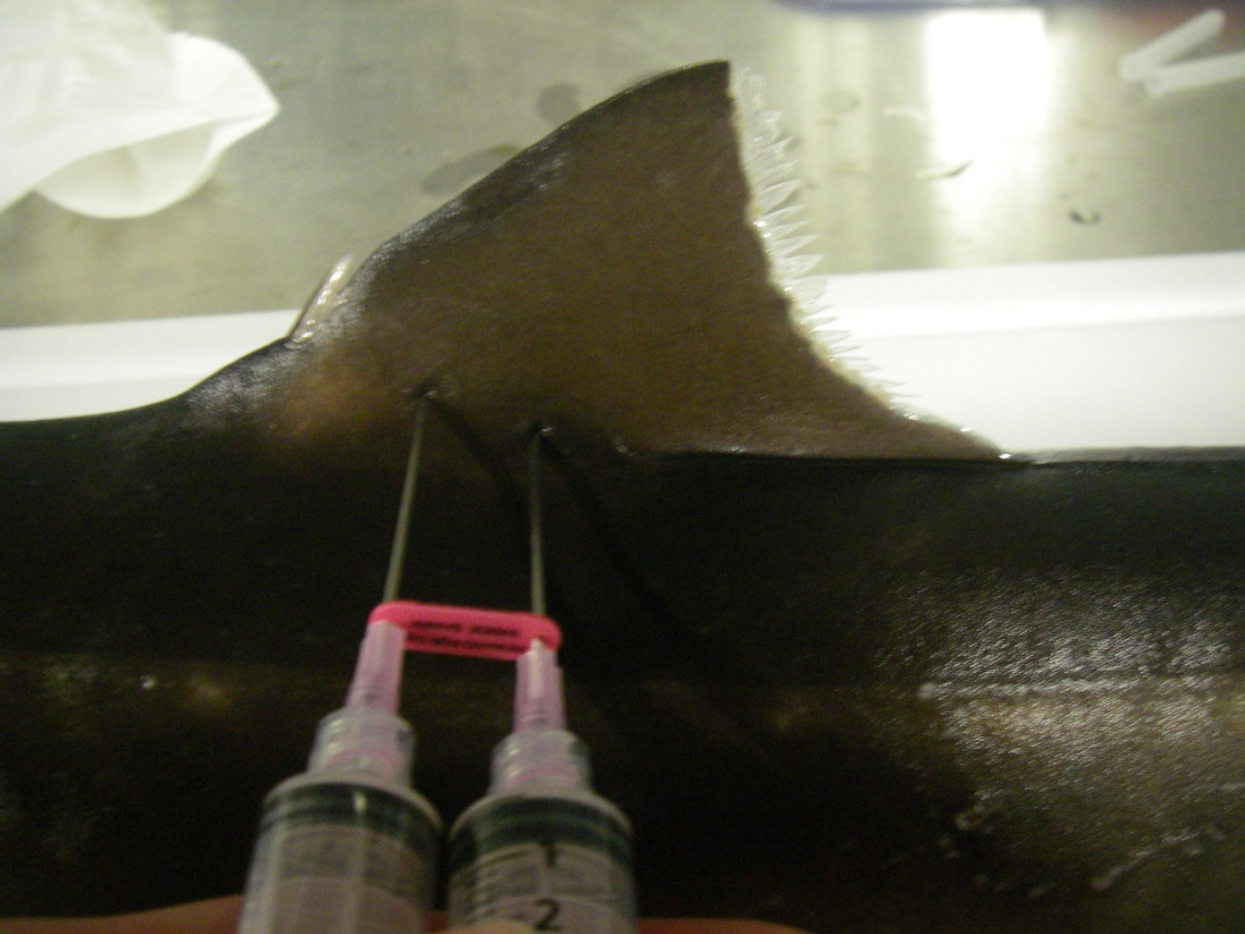

**Step 4.** Use the air in the syringe to expel any tissue in the needle, then feed pins back through needle as far as possible. Slide syringes off pins, tags should be on opposite sides of the fins with pins poking through fins

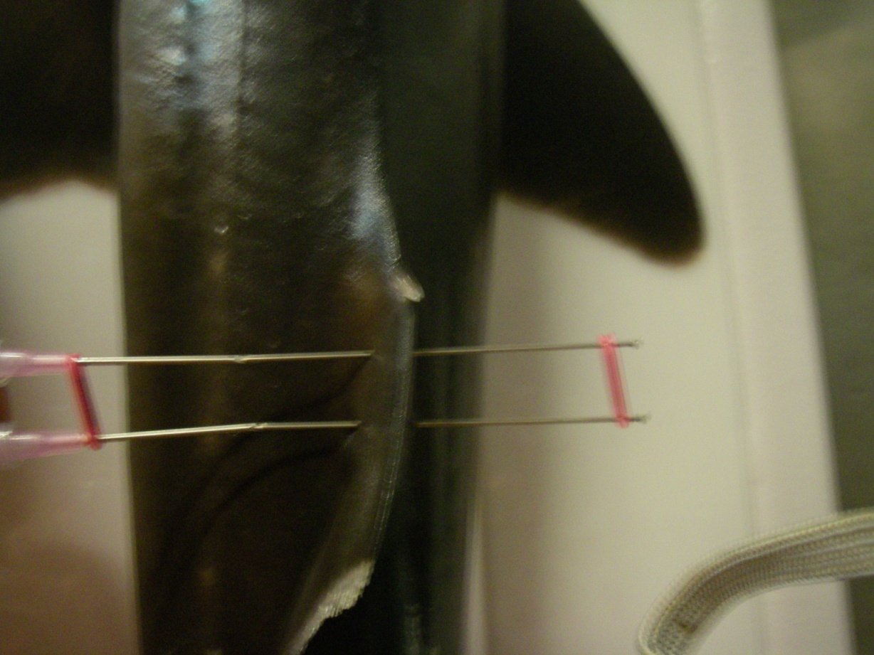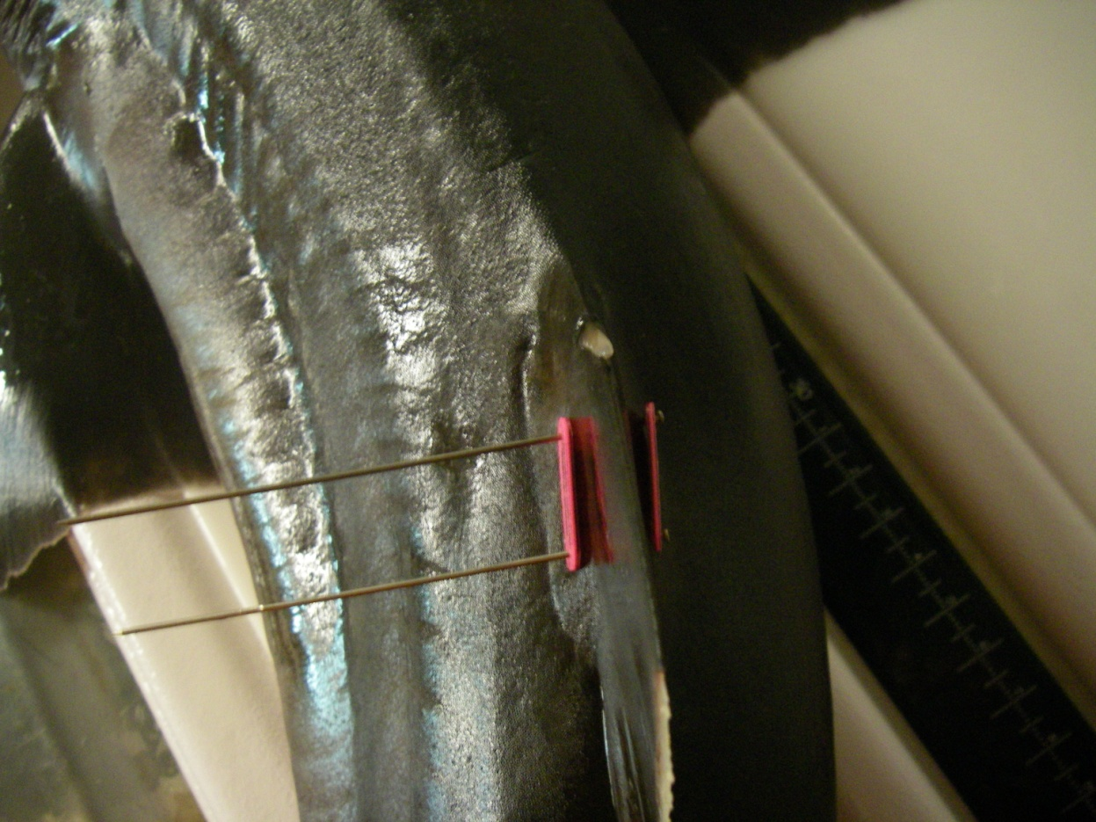

**Step 5.** Cut pins so that about ½” remains. Grab end of 1 pin with tip of pliers and twist end around so that it doesn’t poke into the skin, but the tag will not slide off either. Tag should be resting on fin, not so tight that it could dig into fin and not with enough slack for the pins to wobble and cause injury. Repeat for second pin. Double check for tightness and that sharp ends are not poking the skin.

